1. Concept Map: CPU, Memory, I/O Devices and Bus Structures
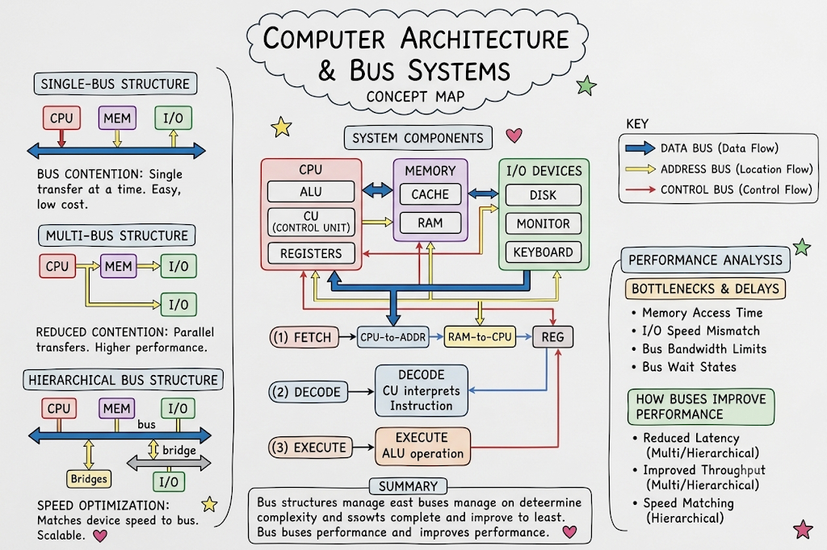

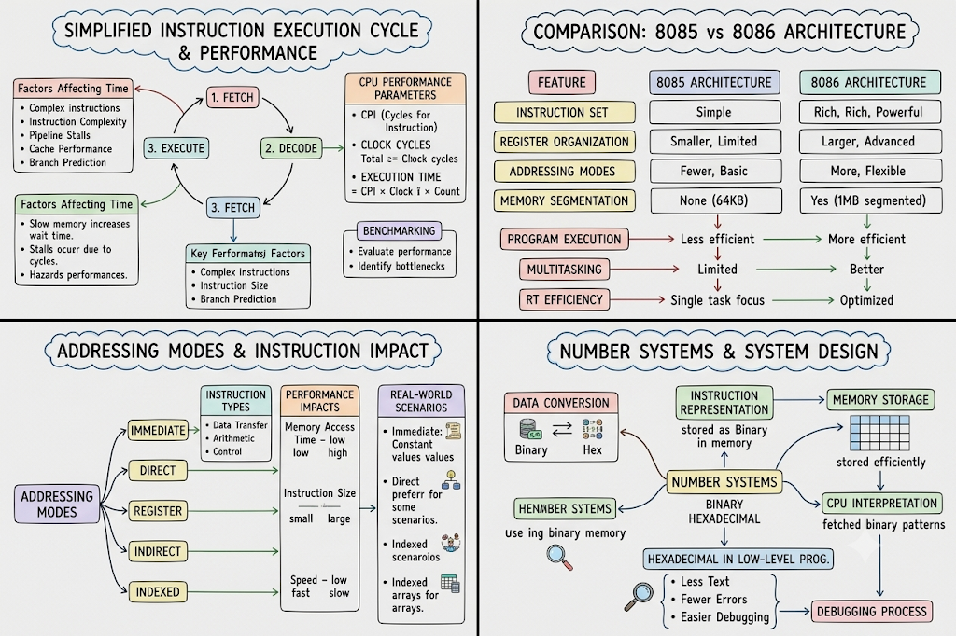
2. Concept Map: Instruction Execution Cycle and CPU Performance

3. Concept Map: Comparison of 8085 and 8086 Architectures

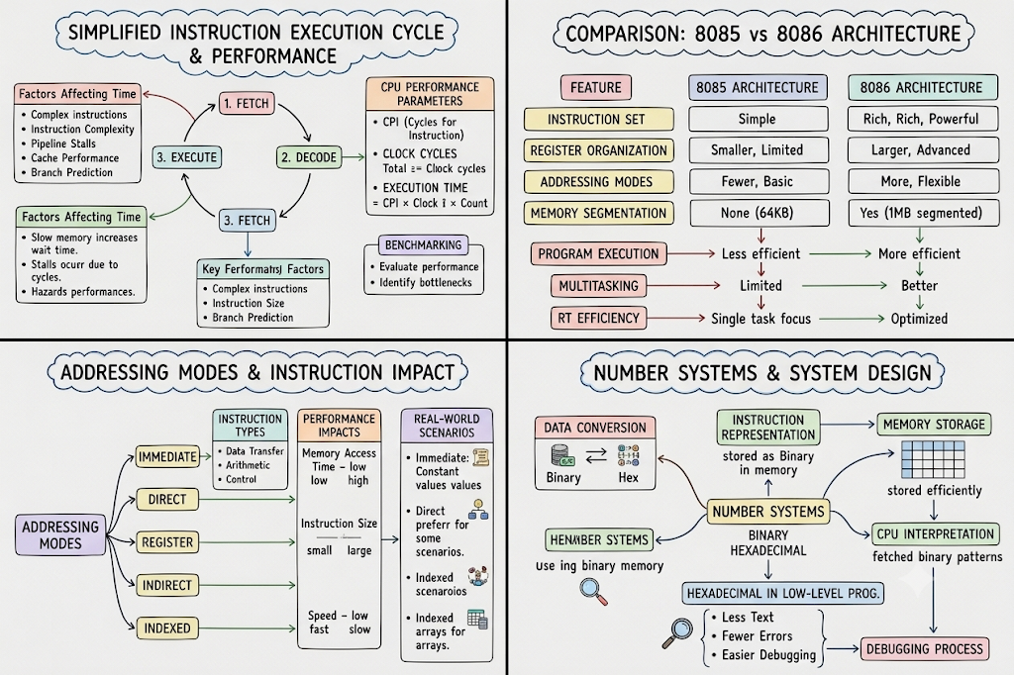
4. Concept Map: Addressing Modes and Instruction Types
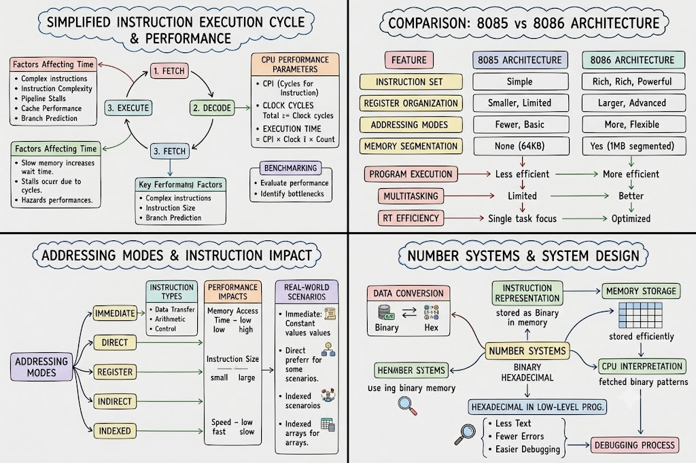
5. Concept Map: Number Systems, Memory Storage and Debugging

